Technical Architecture:

Project Design Phase-II Technology Stack (Architecture & Stack)

Project Name | Cosmetic Insights : Navigating Cosmetics Trends and Consumer Insights
Maximum Marks | 4 Marks

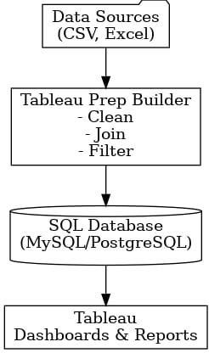

Table-1 : Components & Technologies:

S .No | Component | Description | Technology
1. | User Interface | Interactive dashboard where users analyze trends and filter by region, product | Tableau Embedded Dashboard, Bootstrap Web Portal
2. | Application Logic-1 | Automated data pipeline to pull sales data daily from CRM | online
3. | Application Logic-2 | ETL and transformation: cleaning, aggregating, enriching data | Prep Builder
4. | Application Logic-3 | Custom logic to calculate KPIs, YOY trends, and seasonal analytics | SQL Scripts / Tableau Calculated Fields
5. | Database | Stores sales, customer segmentation, pricing tier, and feedback data | PostgreSQL
6. | Cloud Database | Hosted database that syncs with Tableau | SQL ,Excel
7. | File Storage | Raw datasets (CSV, Excel) and exported reports (PDF, PNG) | Drives
8. | External API-1 | Retrieves public skincare trend data from online sources | None
9. | External API-2 | Integrates demographic or social influence data for  target segmentation | None
10. | Machine Learning Model | Forecast product demand, predict user preferences | None
11. | Infrastructure (Server / Cloud) | Entire solution deployed as microservices with CI/CD pipelines | GitHub

Table-2: Application Characteristics:

S.No | Characteristics | Description | Technology
1. | Open-Source Frameworks | Tableau is a proprietary tool, so no open-source frameworks are used. | Not applicable
2. | Security Implementations | Tableau provides user authentication, row-level security, and data encryption for dashboards | Tableau User Permissions

S.No | Characteristics | Description | Technology
3. | Scalable Architecture | Tableau dashboards can connect to live data sources | Tableau Cloud / Tableau Server
4. | Availability | Tableau Cloud ensures high availability, auto backups | Tableau Online
5. | Performance | Tableau optimizes performance via Hyper Extracts, Dashboard Performance | Tableau Hyper Engine,Extracts

